Contact: Beth Tarson
212-808-1684/Beth.Tarson@Rodale.com

“Riveting, revolutionary and important--not to mention exquisitely written--Agnes's Jacket tells us what we should have been doing all along.”
Joanne Greenberg, author of I Never Promised You a Rose Garden

“An amazing psychological adventure story. Hornstein, an academic psychologist with the skills of a first-rate journalist, enters the world of the truly ‘mad’ and comes out with profound lessons about her profession and herself. In a revolutionary break with therapeutic tradition, she says we need to listen to the voices these disturbed patients hear. But first we need to listen to her!”
Barbara Ehrenreich, author of Nickel and Dimed: On (Not) Getting By in America

Agnes’s Jacket
A Psychologist’s Search for the Meanings of Madness
Gail A. Hornstein

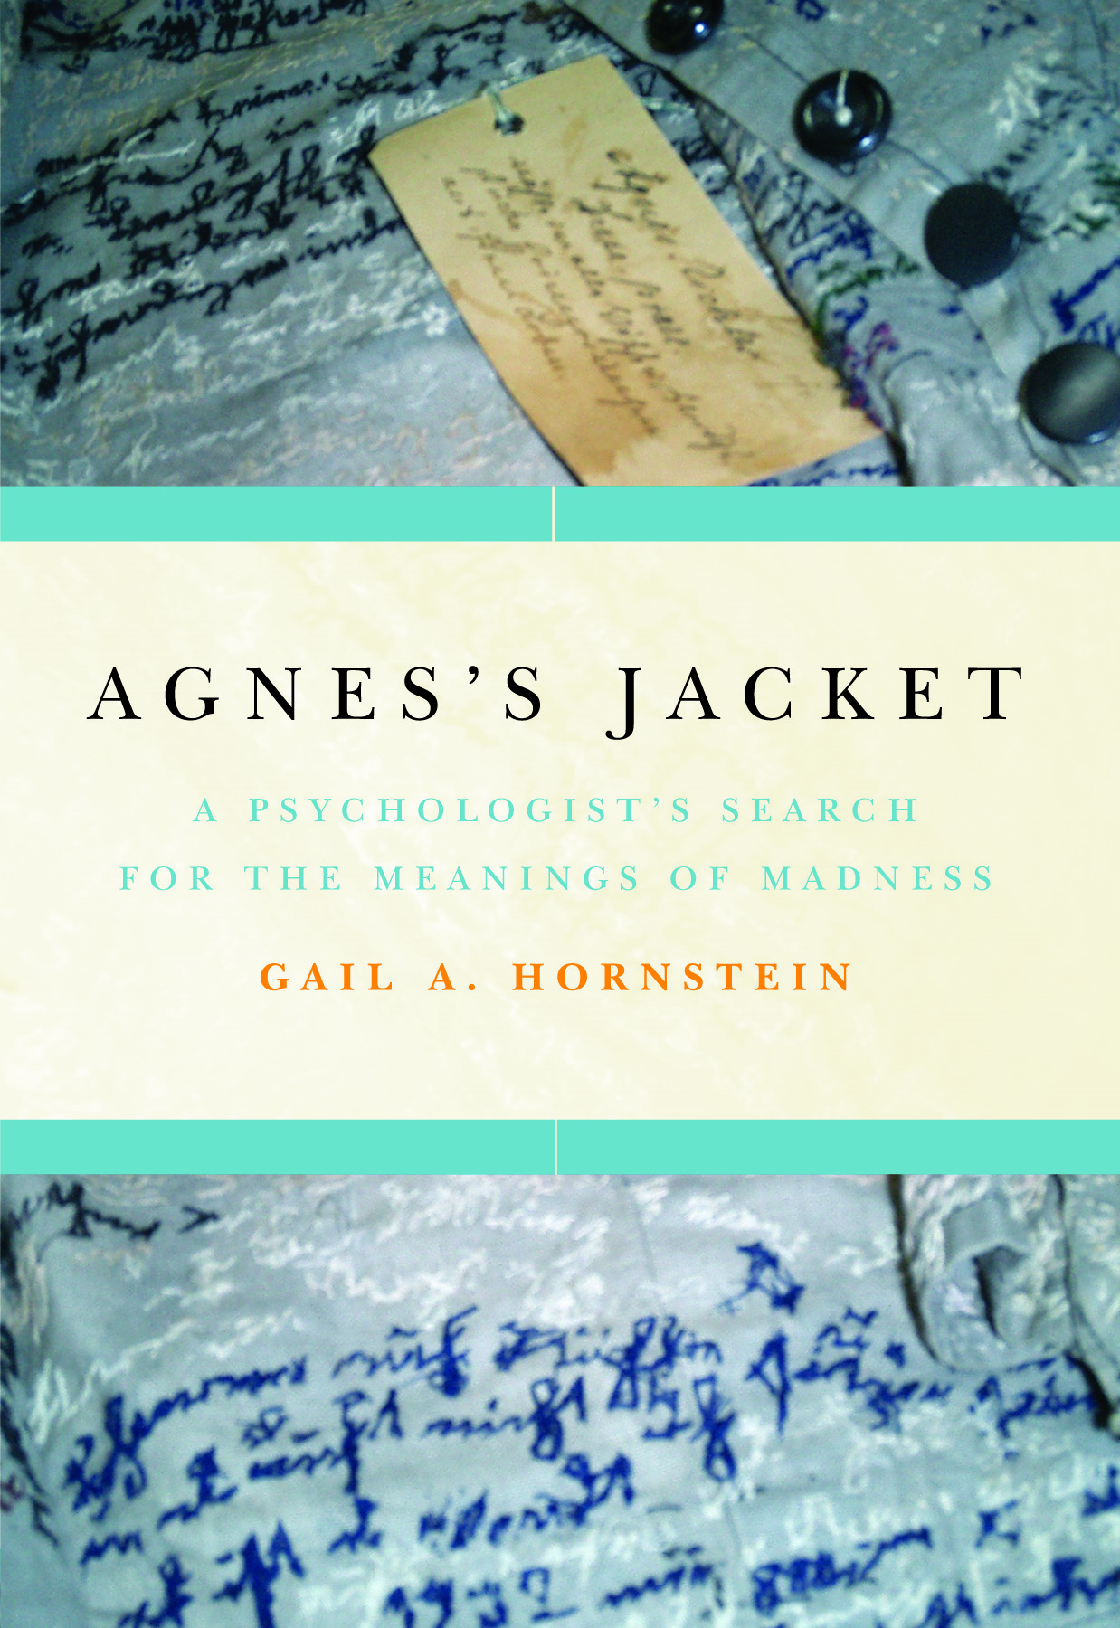
In a Victorian-era German asylum, seamstress Agnes Richter painstakingly stitched a mysterious autobiographical text into every inch of the jacket she created from her institutional uniform. Despite every attempt to silence them, hundreds of other patients have managed to get their stories out, at least in disguised form. Today, in a vibrant underground network of “psychiatric survivor groups” all over the world, patients work together to unravel the mysteries of madness and help one another recover. Optimistic, courageous, and surprising, Agnes’s Jacket (March 17; $25.95; Hardcover) takes us from a code-cracking bunker during World War II to the church basements and treatment centers where a whole new way of understanding the mind has begun to take form.

A vast gulf exists between the way medicine explains psychiatric illness and the experiences of those who suffer. Hornstein’s luminous work helps us bridge that gulf, guiding us through the inner lives of those diagnosed with schizophrenia, bipolar illness, depression and paranoia, and emerging with nothing less than a new model for understanding one another and ourselves.

About the Author:
Gail A. Hornstein is a professor of psychology at Mount Holyoke College and author of To Redeem One Person is to Redeem the World, the widely praised biography of pioneering psychiatrist Frieda Fromm-Reichmann. She divides her time between Holyoke, Massachusetts and London.

Agnes’s Jacket
A Psychologist’s Search for the Meanings of Madness
Gail A. Hornstein
Pub Date: March 17, 2009/$25.95/Hardcover
ISBN 10: 1-59486-544-2/ISBN 13: 978-1-59486-544-2

More Advance Praise for
Agnes’s Jacket

“Gail Hornstein is one of the enlightened ones. A psychologist who is listening, letting patients speak for themselves, daring to challenge the prevailing 'wisdom' in her field, and thinking outside the chemical box. This book is a testament to the power of first person testimony and the inestimable, healing value of it in the treatment of the mentally ill. May her persistent humility and compassion lead the way to a more progressive model of mental health.”
Norah Vincent, author of Self-Made Man

“Compelling and beautifully done.”
Susie Orbach, author of The Impossibility of Sex: Stories of the Intimate Relationship between
Therapist and Patient

“Agnes’s Jacket takes readers on a mesmerizing journey ... Every page is animated by Hornstein’s curiosity, her candor, and her evident empathy for those who have bravely welcomed her into their lives.”
Robert Whitaker, author of Mad in America

“A journey into worlds most of us have never heard of, where the question becomes not ‘what’s wrong with you’ but ‘what happened to you, and how did you manage to survive?’ In an age riveted by brain scans and talk of chemical imbalance, Agnes’s Jacket bears witness to the fact that the mad are carrying stories they need to tell. As Hornstein reminds us, madness is more code than chemistry.”
Carol Gilligan, author of In a Different Voice

“An engaging and genuinely progressive piece of research and analysis. Hornstein is refreshingly frank about the complicated responses of patients, and deftly raises questions about authority, who speaks for whom, and why."
Dorothy Allison, author of Bastard Out of Carolina

“Useful, passionate, and well-informed … distinguished by its understanding of what madness is and feels like to those who experience it.”
Jay Neugeboren, author of Imagining Robert and Transforming Madness

“Hornstein attacks the stigma attached to mental illness with enormous originality and imagination … She has brought into the light a true literature of protest.”
Patrick McGrath, author of Spider and Trauma

