Reading and Book Signing
Odyssey Bookshop, South Hadley, MA
March 26 • Thursday • 7 pm

Free and open to the public. Call (413) 534-7307 to reserve a space. If you can’t attend, a signed book can be reserved for you.

Agnes’s Jacket
A Psychologist’s Search for the Meanings of Madness
Gail A. Hornstein

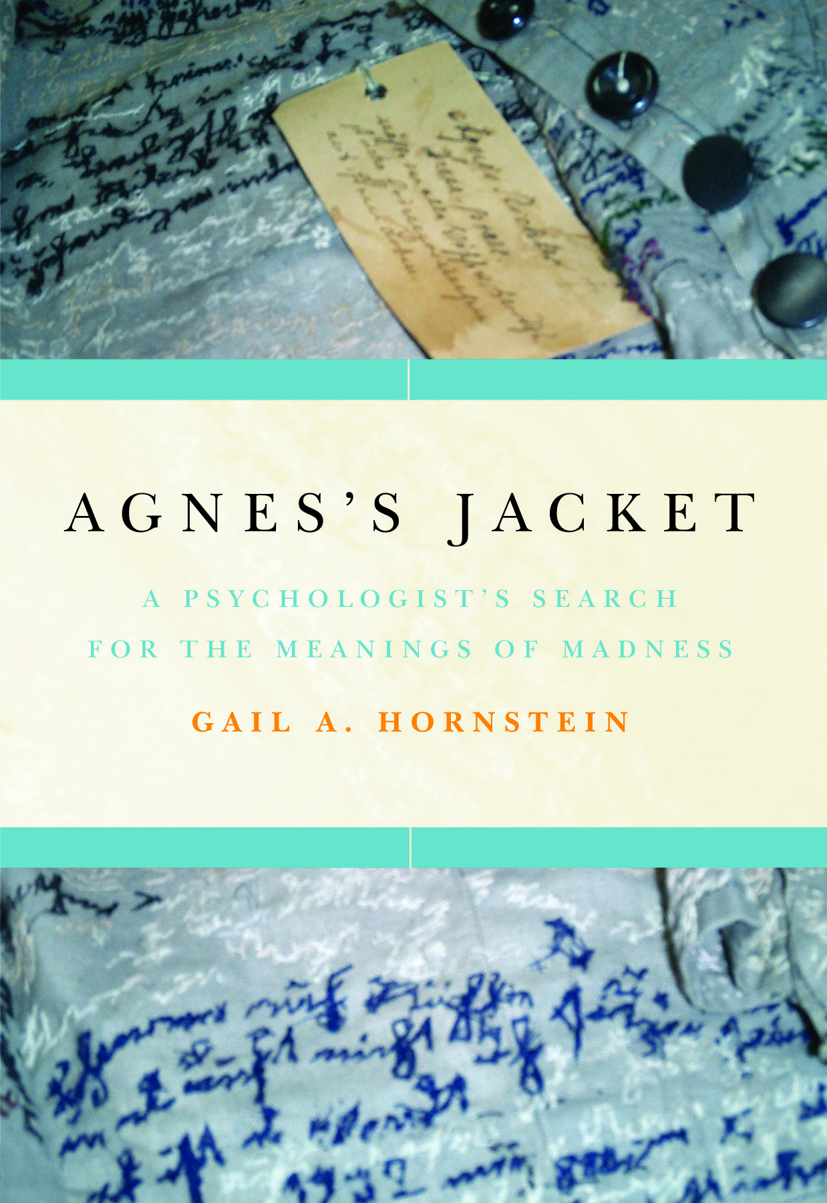
In a Victorian-era German asylum, seamstress Agnes Richter painstakingly stitched a mysterious autobiographical text into every inch of the jacket she created from her institutional uniform. Despite every attempt to silence them, hundreds of other patients have managed to get their stories out, at least in disguised form. Today, in a vibrant underground network of “psychiatric survivor groups” all over the world, patients work together to unravel the mysteries of madness and help one another recover. Optimistic, courageous, and surprising, Agnes’s Jacket (on sale starting March 17; $25.95; Hardcover) takes us from a code-cracking bunker during World War II to the church basements and treatment centers where a whole new way of understanding the mind has begun to take form.

A vast gulf exists between the way medicine explains psychiatric illness and the experiences of those who suffer. Hornstein’s luminous work helps us bridge that gulf, guiding us through the inner lives of those diagnosed with schizophrenia, bipolar illness, depression and paranoia, and emerging with nothing less than a new model for understanding one another and ourselves.

“Riveting, revolutionary and important--not to mention exquisitely written--Agnes's Jacket tells us what we should have been doing all along.”
Joanne Greenberg, author of I Never Promised You a Rose Garden

“An amazing psychological adventure story. Hornstein, an academic psychologist with the skills of a first-rate journalist, enters the world of the truly ‘mad’ and comes out with profound lessons about her profession and herself. In a revolutionary break with therapeutic tradition, she says we need to listen to the voices these disturbed patients hear. But first we need to listen to her!”
Barbara Ehrenreich, author of Nickel and Dimed: On (Not) Getting By in America

